**KGR-ROTARACT**

REPORT

ON

**"PLANTATION OF SAPLINGS"**

BY

( SECRETARY ) Rtr. SHIVANI GUPTA

KGR-ROTARACT. HoD-DSA. PRINCIPAL

( Secretary )

**OBJECTIVE OF PLANTATION**

The campaign's main aim was to direct student's mind in constructive activities with the positive outcome through the facilitation of contributing to the society

The idea behind the tree plantation activity was to propagate the message that planting the trees helps to maintain clear eco-friendly environment reduces pollution and improves the green ambience.

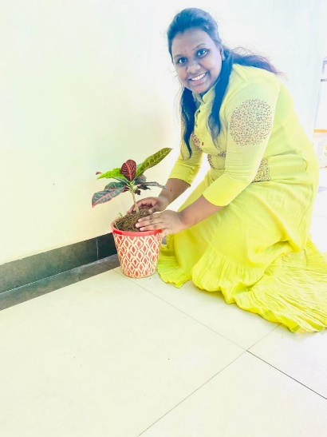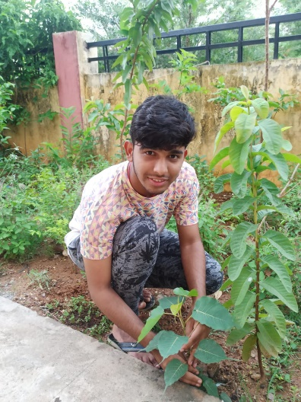 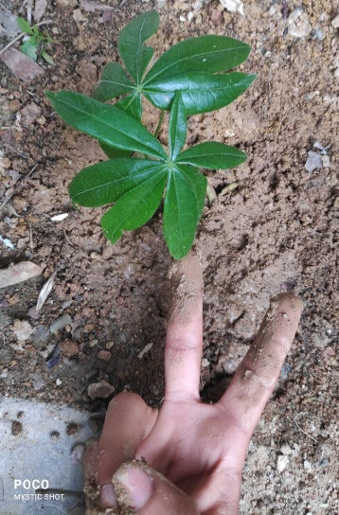

**Rtr.Meghana Sharon Rtr. Hrushinath Rtr. Tarun kotagiri**